*Children Vaccination system*

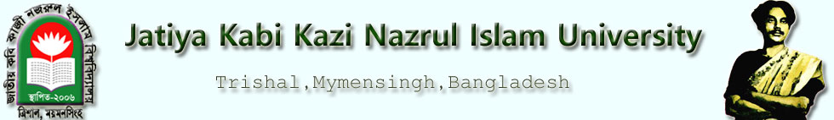

**Course Name: Software Development Project-II**

**Course Code: CSE -200**

**Supervised By**

Dr. A H M Kamal

Professor

Dept. of CSE, JKKNIU

**Submitted By**

Md. Atahar Ishrak Md. Zawharul Islam

Roll:18102020 Roll:17102014

Reg. No*.*6731 Reg. No.5691

**Department of Computer Science and Engineering**

**JATIYA KABI KAZI NAZRUL ISLAM UNIVERSITY, MYMENSINGH**

CANDIDATE’S DECLARATION

We declare that this project is my own work and has not been submitted in any other form for another degree or diploma at any university of other institute of tertiary education. Information derived from the published and unpublished work of others has been acknowledged in the text and a list of references is given.

Date: 23-02-2020 Signature of the Candidates

_____________________

_____________________

Name of the Candidates

Md. Atahar Ishrak

Md. Zawharul Islam

As a supervisor, I authorize that the work is done under by close guidance. I have given approval to submit that report to go for evaluation.

Date: 23-02-2020 Signature of the Supervisor

_____________________

Dr. A H M Kamal

Professor

Dept. of CSE, JKKNIU

DEDICATION

we dedicate this project to our parents.

**Table of Contents**

**Chapter 1 (Introduction)**

* 1. Introduction
  2. Objective

Outline

**Chapter 2 Methodology**

2.1 Algorithm

Outline

**Chapter 3 (Result and Discussion)**

3.1 Experimental Result

3.2 Limitation

Outline

**Chapter 4 Conclusion**

4.1 Conclusion

4.2Future Scope

***References***

List of Tables and Figures

***Acknowledgements***

A project is a golden opportunity for a student to learn and self-development. We consider ourselves very lucky and honored to have so many wonderful people who lead us through in completion of this project.

My grateful thanks to Dr. A H M Kamal sir who in spite of being extraordinarily busy with his duties, took time out to hear, guide and keep us on the correct path. We do not know where we would have been without him.

Last but not the least there were so many who shared valuable information that helped in the successful completion of this project.

**Authors**

Md Atahar Ishrak

Roll: 18102020

Md. Zawharul Islam

Roll: 17102014

*Children Vaccination system*

**Chapter – 1**

**Introduction**

Vaccines are very important for your child; it protects your child against various dreaded diseases like tetanus, diphtheria, pertussis (whooping cough), polio, measles, hepatitis B, haemophilus influenza type b (which causes some meningitis and pneumonia), yellow fever, tuberculosis, etc. Apollo Vaccination Centre offers a range of vaccinations not only for your child, but also for adults and travellers. Patients are immunized at our Centre as per the Extended Program of Immunization (EPI) of World Health Organization (WHO) protocols.

Children vaccination system is the group of processes of health care service providers that are responsible to collect children age and vaccine information, produce the essential vaccine in the specified age.

A vaccination system is a govt application software designed to support the health care processes.

Below is a list of the essential benefits of Vaccination system in the health sector.

1. Reducing faults associated with children age
2. Advantage over health care management
3. Screening of matching records
4. Availability of detailed vaccine information

*1.2 Objectives*

The objectives of this project are as follows:

1. Develop Children vaccination system through which one can do the following jobs:
   1. Add children records
   2. Lists the records
   3. Search the information
   4. Delete the records
2. while implementing the project Children vaccination system we minimize time to increase the speed of work done.
3. To develop a basic software which will help the health workers the most satisfying service to the people.

*Outline*

Chapter 2 is the process of the program. The name of the Chapter is Methodology. In this chapter there are three part ,2.1 Algorithm, 2.2Analysis & Design

**Chapter-2**

*Methodology*

Here we implement the concept of management system. We make a feature of normal management system. Then we add many functions, structure, parameter to implement theChildrenvaccinationsystem in java program.

*Outline:*

Chapter 3 is Result & Discussion. In this chapter, we discussion about experimental Result & Limitation.

**Chapter-3**

***Result and Discussion***

**Add Children:** This is used Enter the Information about The consumer like Id, Name ,Father’s name ,City ,Age ,Sex ,Vaccine Number ,Phone Number then we save it in database. so that we can use these information in future.

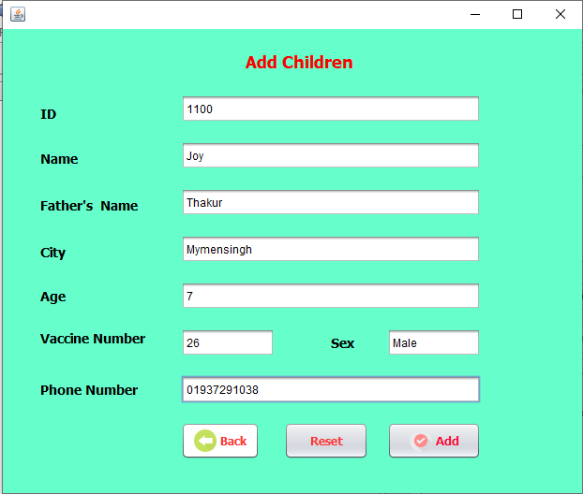

**List of Vaccine information and save information :** This is used to show all the information we saved in the database.

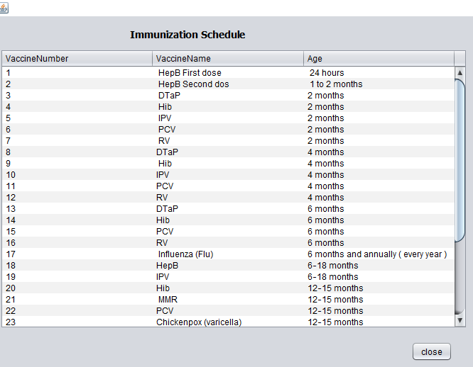

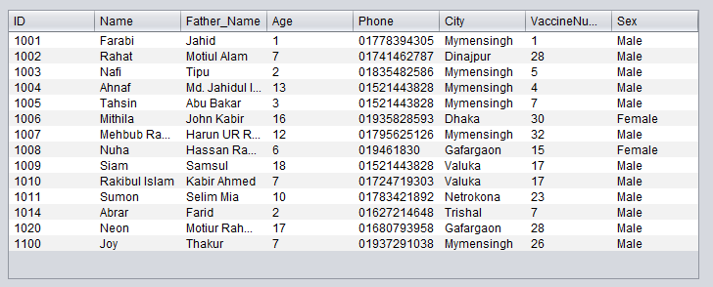

**Search information:**This is used to find a specified information from ta database . search option compare the information with the database information. If it found matched then show the information to the user.In this project There are two kind of search option one is normal and the other is the advance search. We can search by Id, City, Vaccine number.

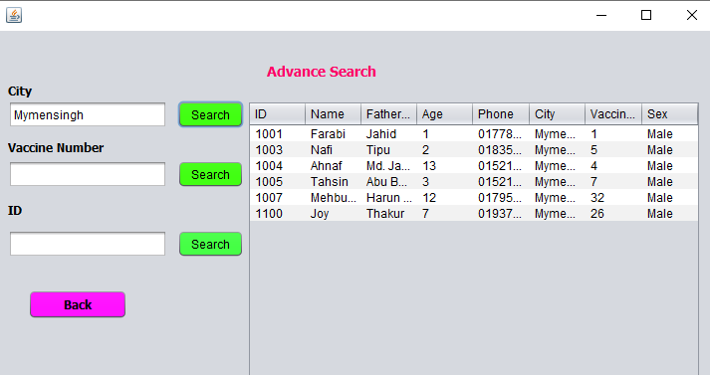

**Update Information:** This is used to update information we save in the database. We enter a id nuber number to find a information .If we find the information then we can change Age ,vaccine number and city.

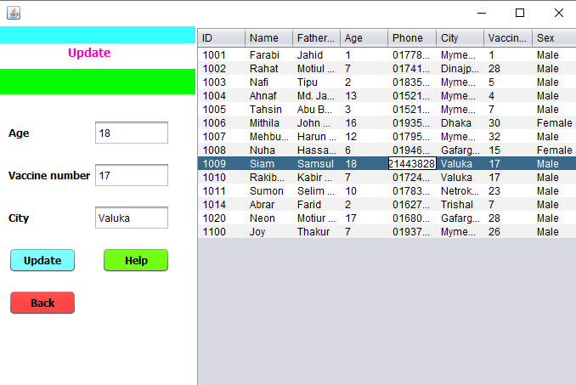

**Delete Information:** This is used for deleting a record from the database.We enter a Id number to compare with the Id number saved in the database and if they match then the record is deleted.

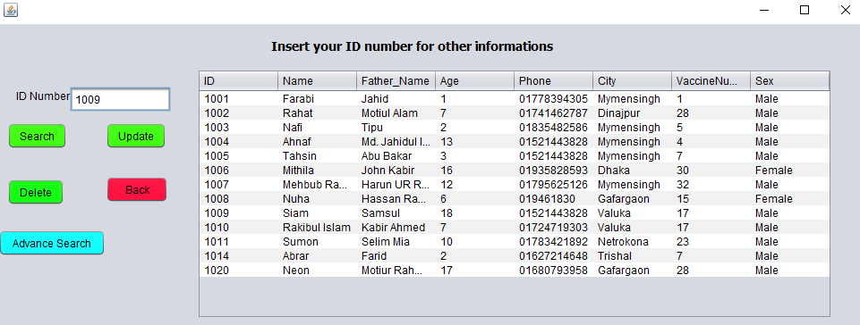

***3.2 Limitation***

The limitation of the project is as follows:

1.This software is single person based software.

2.After updated we can not save the past information.

3.We also did not use month for add , search information.

*Outline:*

The final chapter is Conclusion.

**Chapter-4**

***Conclusion***

***4.1 Conclusion***

In this report, we have shown the Procedure of developing Childrenvaccinationsystem. We have some limitation in our developed system which we will over future.

***4.2 Future Scope***

As we said earlier that After updated we can not save the past information and we also did not use month for add , search information now but we hope in future time we will be solve this problem and make this ChildrenvaccinationSystem more efficient and useful.

***References***

1. **Five Important Reasons to Vaccinate Your Child , U.S. Department of Health & Human Services**  [**https://www.vaccines.gov/getting/for_parents/five_reasons**](https://www.vaccines.gov/getting/for_parents/five_reasons) **.**
2. **Health topics vaccines,** [**https://www.who.int/southeastasia**](https://www.who.int/southeastasia)**.**
3. **Global Health Observatory data , Explore a world of health data, Bangladesh** [**https://www.who.int/data/gho/data/countries/country-details/GHO/bangladesh?countryProfileId=f4f4d019-157e-4c15-b9f0-8f67f79a44fc**](https://www.who.int/data/gho/data/countries/country-details/GHO/bangladesh?countryProfileId=f4f4d019-157e-4c15-b9f0-8f67f79a44fc).
4. **Java The complete reference**  *Seventh Edition. Herbert Schildt.*